9th Annual Fire Tower Lighting Event

The original premise for the Lighting of the Fire Tower Event came from Doug Hamilton of the Red Hill Fire Tower Committee. The idea was to light the fire tower with a high powered light, put lots of press releases in the local paper about the time when this would occur and invite people to go to locations around the community where they could look up, see the light on the horizon and remember that there was a fire tower there watching over and protecting the community and surrounding forest.

This year several towers will be participating statewide. To see the locations that are visible from a tower near you, simply click on the tower you hope to see on this web page: http://nysffla.org/light.html and then go to one of the locations noted and see if you can see the light!

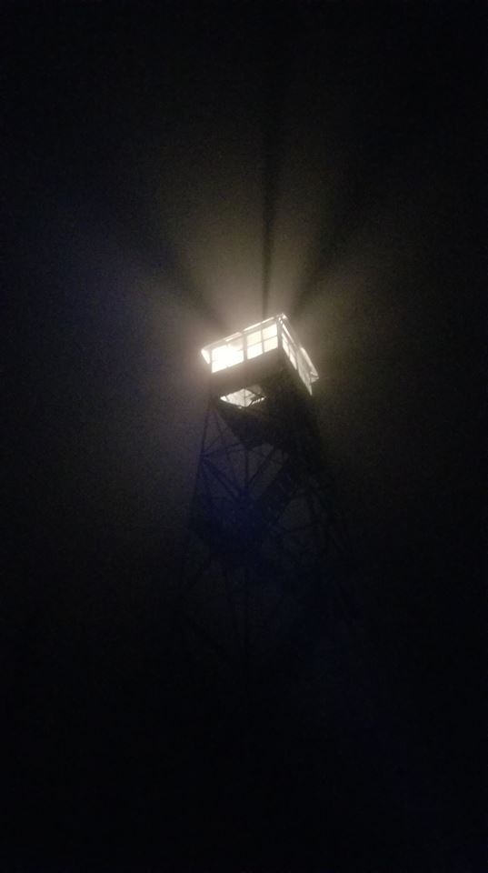
The event will happen on Saturday, September 3rd from 9-9:30pm. The rain date will be Sunday, September 4th at the same time. For additional information, questions or to include a tower not listed, please contact Laurie Rankin, Director New York State Chapter Forest Fire Lookout Association at lauriejrankin@gmail.com

